Week 10: St. Clare/Agnus Dei
“Considering that the blessed life we so long for consists in an intimate and true love of God Our Creator and Lord, which binds and obliges us all to a sincere love.” - St. Ignatius of Loyola
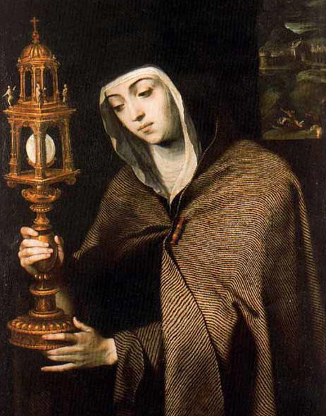
St. Clare of Assisi
- b. 1194-d.1253, Chiara Offreduccio’s story is commonly heard alongside Francis’ story; however, the two have unique albeit intertwined vocations and spiritual lives. Both were children of wealthy families in the small town of Assisi and met in the early 1200s, and although Clare was 15 years younger than Francis, the two were drawn to each other.
- While Clare’s mother was pregnant with her, she was reported to have heard a mysterious voice which told her that she would bring a bright light to the world. Writers have described Clare as radiant after she would finish praying. They even reported that the spot where she had been praying would remain illuminated after she left.
- By the time Clare was 18 she had met Francis several times for Spiritual Direction. On Palm Sunday, in the year 1212, Clare sneaked out of her house to join Francis. He shaved off all of her hair, so that her family would know, when they tried to reclaim her, that her decision to leave was final, since no suitor would be interested in her anymore now that she was shorn. Francis procured a spot for her to stay with the Benedictine nuns until he was able to find her a place of her own.
- A few weeks later, Clare’s sister, Agnes, left home to join Clare. Her parents were even angrier now, but they could not get Agnes to return home. In fact, it is said that Agnes’ body became so heavy that nobody could carry her. Years later, Clare’s youngest sister, Beatrice, and her mother, Ortulana, also joined Clare’s order.
- Soon after, Francis procured San Damiano as a place where the Poor Ladies could live, and as soon as they settled themselves there, other women from the region swiftly gathered around her. Clare did not want to have official charge over the women, but finally after 3 years, and at Francis’ insistence, she accepted the role of mother that the other women had placed on her already.
- Clare had no possessions, neither did any of the sisters who lived with Clare. One of the mandates of her order was that before joining, they must give all their possessions to the poor. Clare herself lived with very little, and in fact during some of the early years her health suffered greatly because of the care and nourishment for her body that she joyfully and continually flung aside. Francis finally told her that she must take at least some food every day and that death to worldly things is not a physical death, but a spiritual detachment.
- Clare refused any sort of endowment that was offered to her order. She did not want to be under the church’s control, but under God’s control. She knew that God’s instruments, the brothers and the people of Assisi, would take care of all of their needs. Even after Francis’ death, the brothers continued to care for the sisters at Francis’ mandate. The sisters never left their cloister, so alms were either collected by the brothers or dropped off at their door.
- Clare’s prayers were powerful. They were told to have brought food, healing, and even protection for the sisters and even one time for Assisi, when Clare prayed that an army advancing on the city would not attack, and indeed, they turned around and left.
- Francis died in 1226, only 14 years after the sisters were established at San Damiano, and 27 years before Clare’s own death. The two are linked not only by their care for one another (although their actual visits with each other were rare) but by their deep trust and faith in God who sustained both of their lives in a way that drew hundreds of people to them in a very short time. Their love for each other and their love for God exuded from them, nourishing all who came in contact with them.
- Francis sent one of his brothers to Clare to be healed of a mental illness. She made the sign of the cross over him, he slept for a while, and then awoke well. He sent five women to her one time to be received into her order. She said she would only take four because the fifth would not persevere. She was pressured to receive all five, and as she sensed from first glance, the fifth left after a few months. All these accounts and many more were told by her sisters at her canonization which happened only two years after her death.
- Throughout St. Clare’s life, she attracted many women from near and far into her order. One with whom she never met, but shared a great deal of correspondence was Princess Agnes of Prague. In her letters to Agnes are found some of her most famous words:

“What you hold, may you always hold. What you do, may you always do and never abandon. But with swift pace, light step, unswerving feet, so that even your steps stir up no dust, may you go forward securely, joyfully, and swiftly, on the path of prudent happiness.”

“Place you mind before the mirror of eternity!
Place your soul in the brilliance of glory!
Place your heart in the figure of the divine substance!
And transform your entire being into the image of the Godhead itself through contemplation.”

Reflection Questions:
Consider a time of transition in your life. How did that transition precipitate? What were the stresses and comforts that were present during that time of change? Take a moment in prayer to sit with that experience while feeling God’s love and presence with you throughout all of the emotions of that time. Do any words come to your heart that might describe your sense of God?

As Clare walked through the dark night from her childhood home and family to the tiny church where Francis and his followers stayed, what is your sense of what she walked away from? What is your sense of what she walked towards?

Imagine Clare showing up at the Portiuncula in the middle of the night. She and Francis may have shared the peace of God upon her arrival. While imagining this moment speak softly or think the words of the Agnus Dei. What blessings do we receive when we receive God’s mercy? Do any words or images arise for you when you consider God’s mercy in your life?

It was said that after Clare finished praying, the spot where she had been would remain illuminated for a time after she left. Can you describe a time when a sense of light or clarity remained with you after a time of prayer?

